Lab 1

1. Final Dockerfile

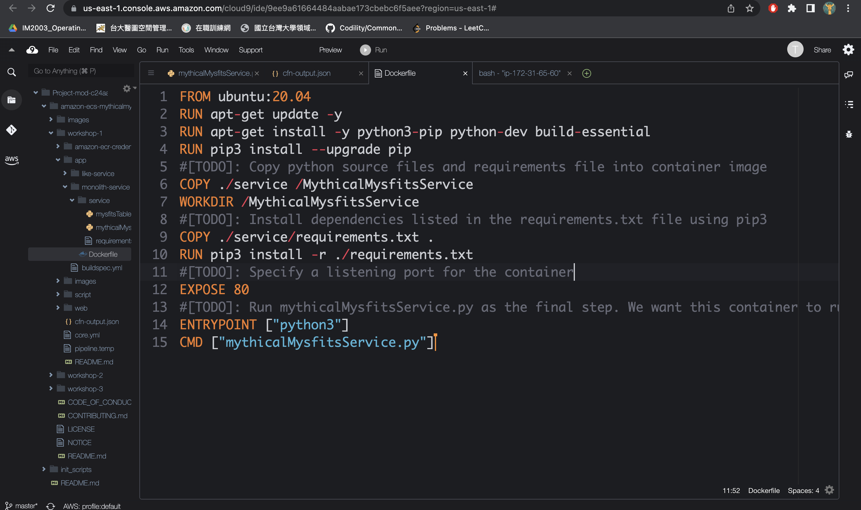

1. Docker Build

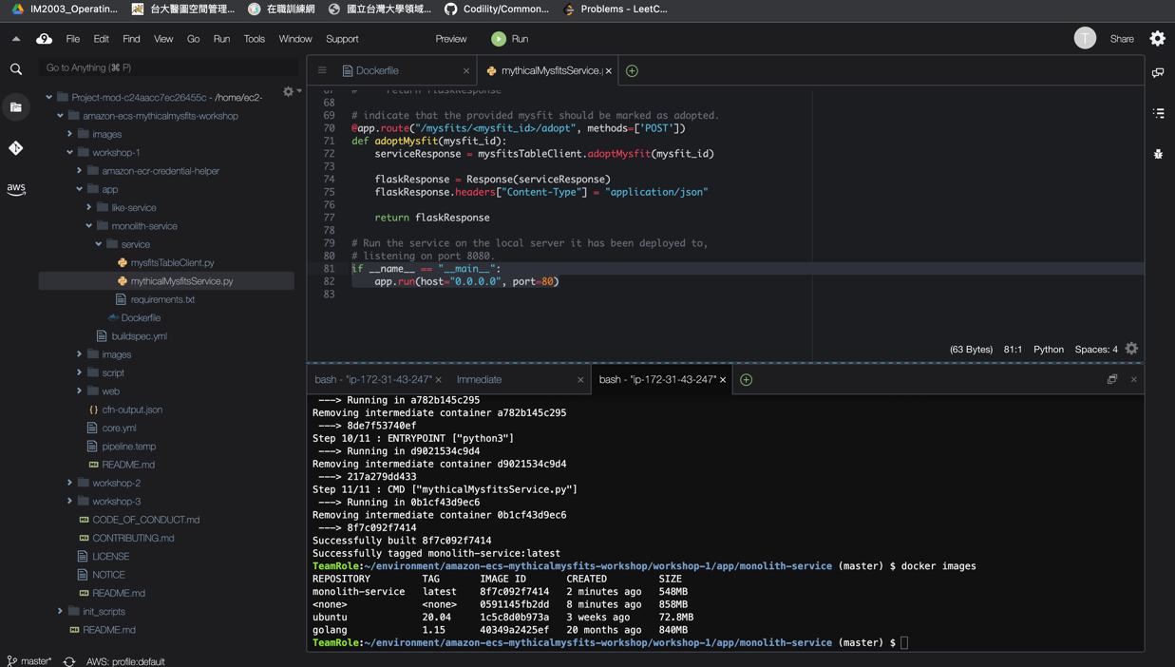

1. Curl result

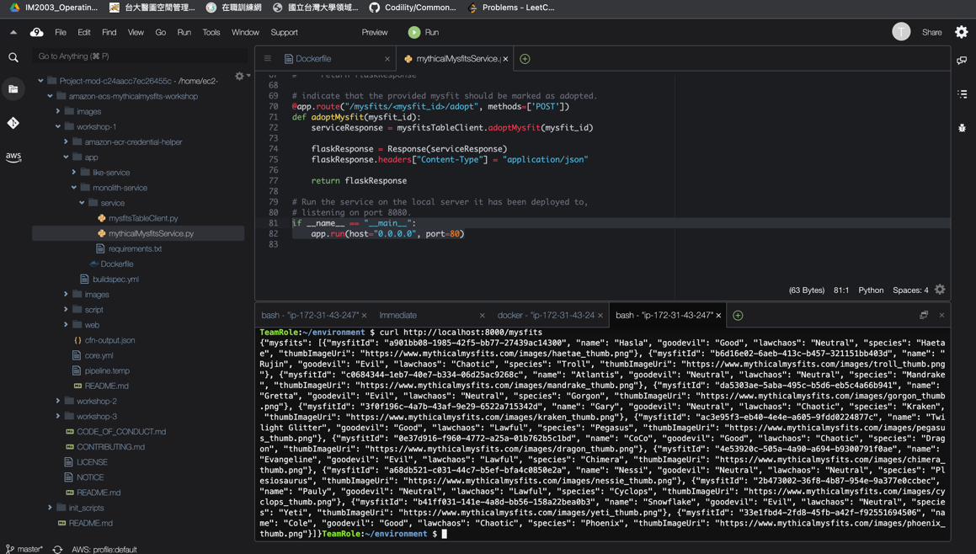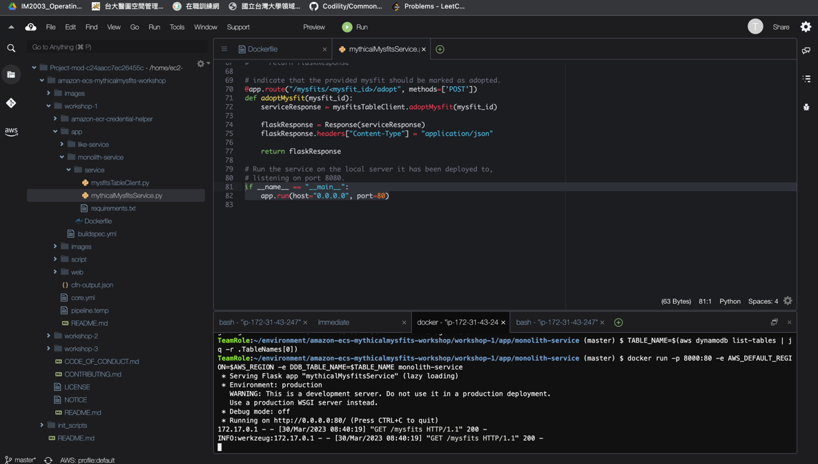

1. Docker pushes the layers up to ECR

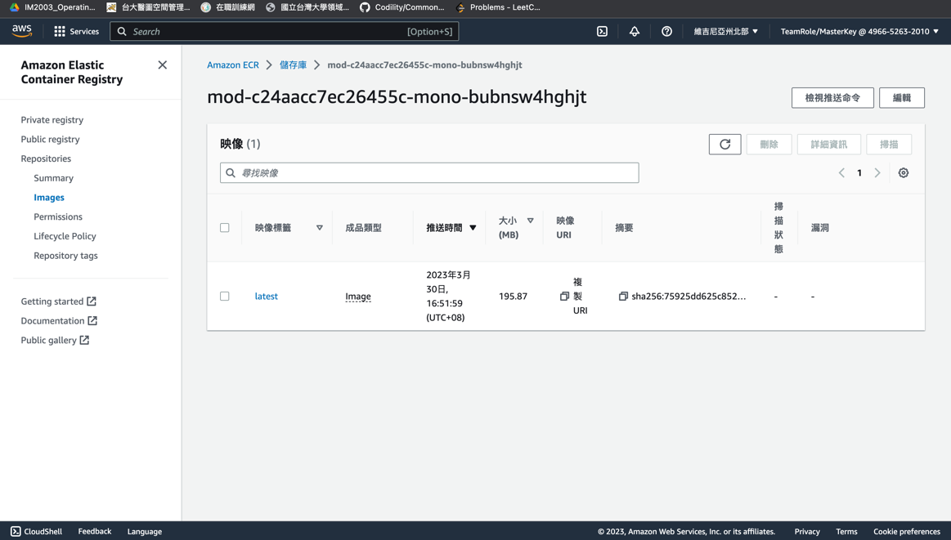

Lab 2

1. Create new task

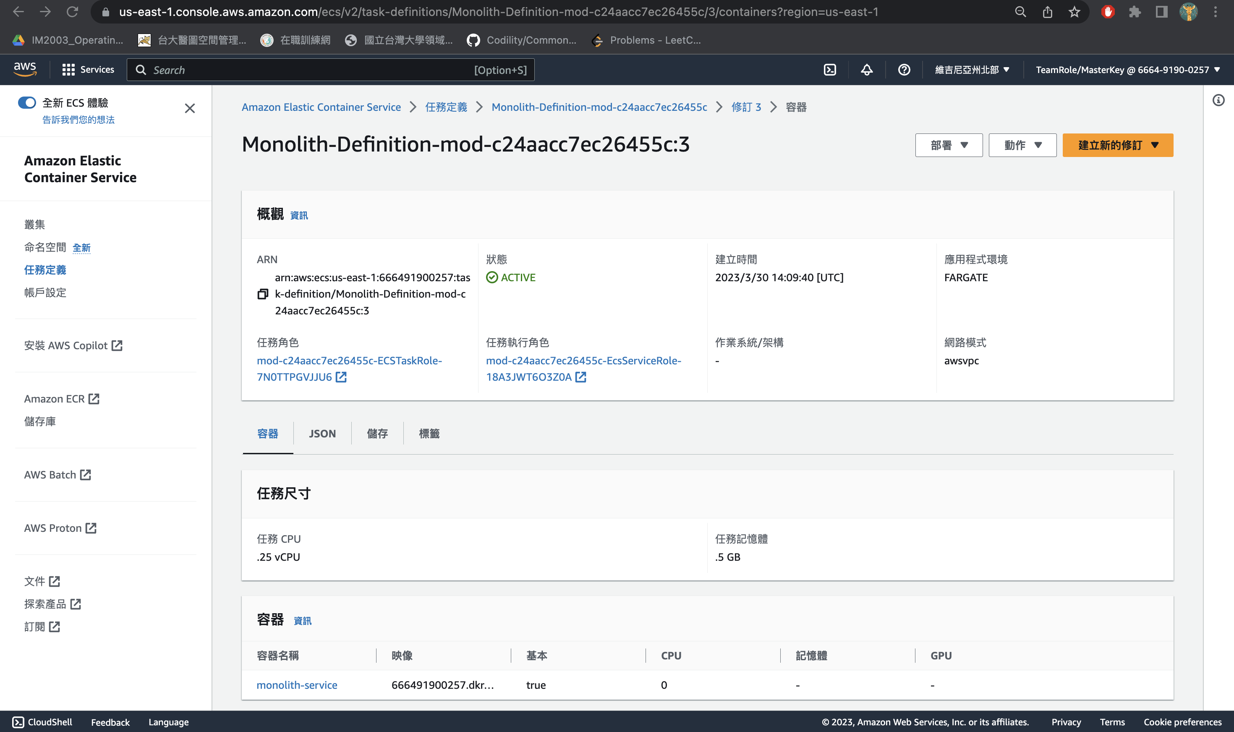

1. Run task

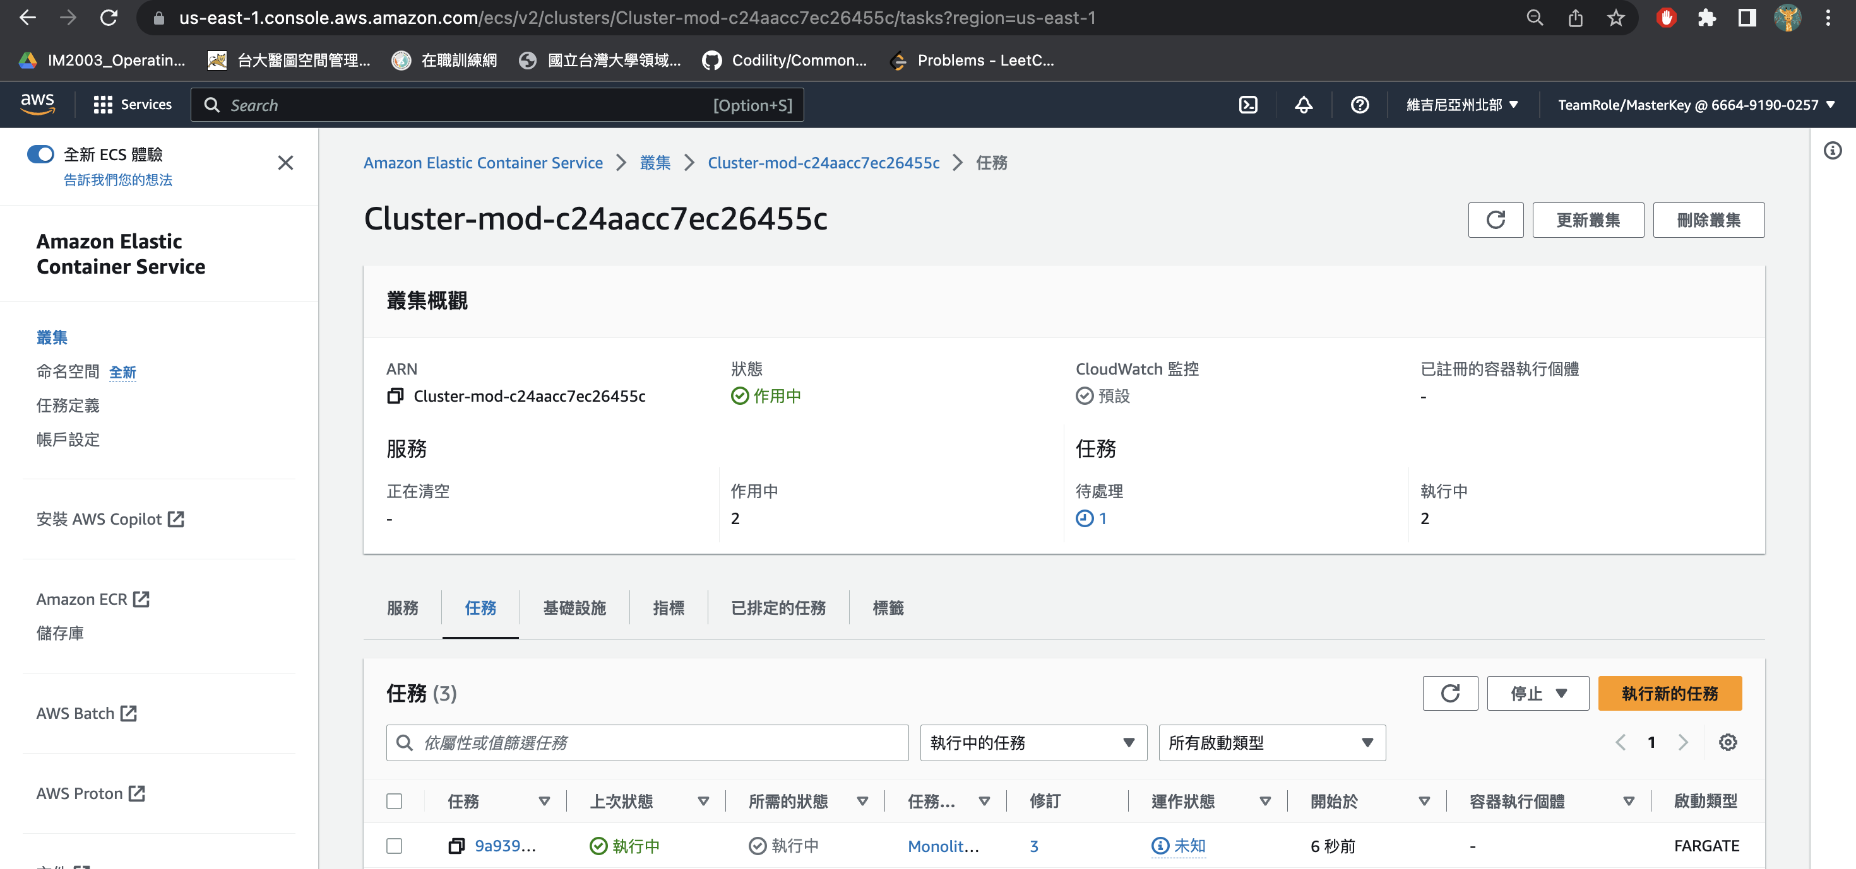

1. curl <http://TASK_PUBLIC_IP_ADDRESS/mysfits>

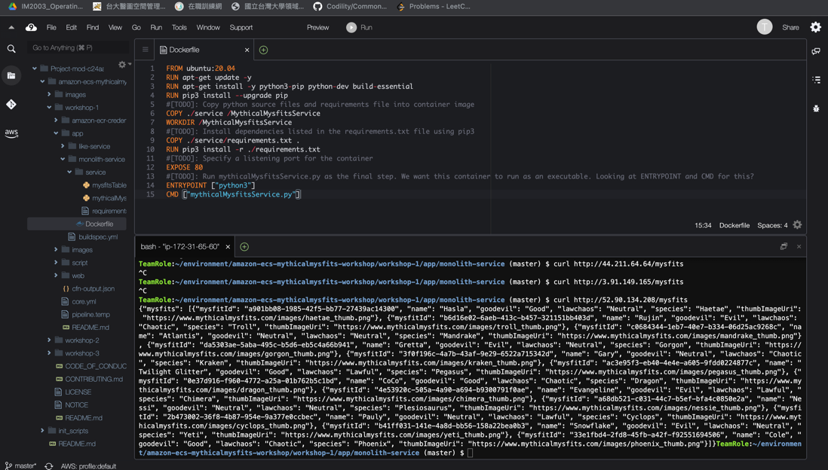

1. CloudWatch Logs dashboard

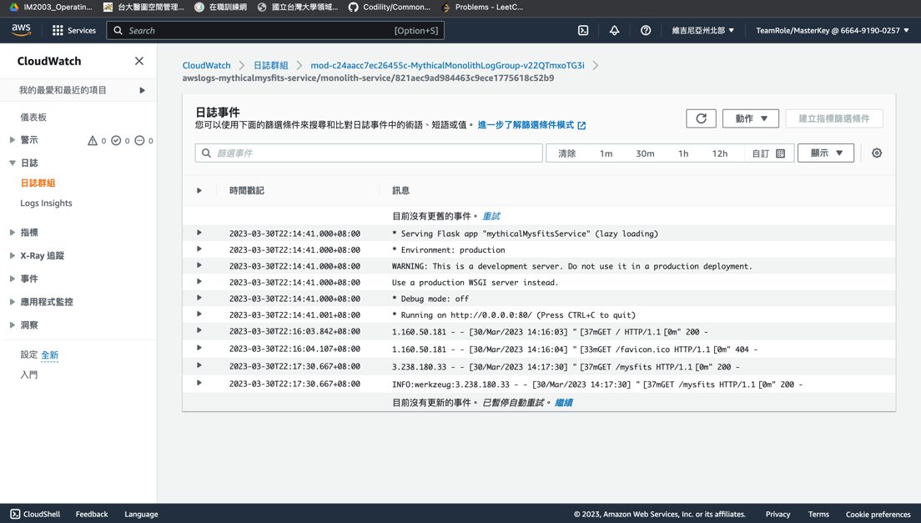

1. Stop the task

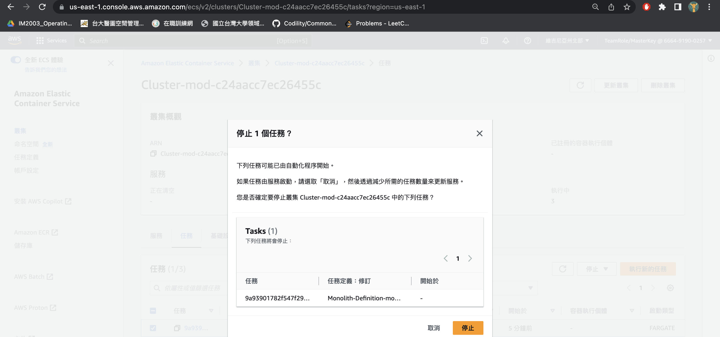

Lab 3

1. Update the service to use your task definition

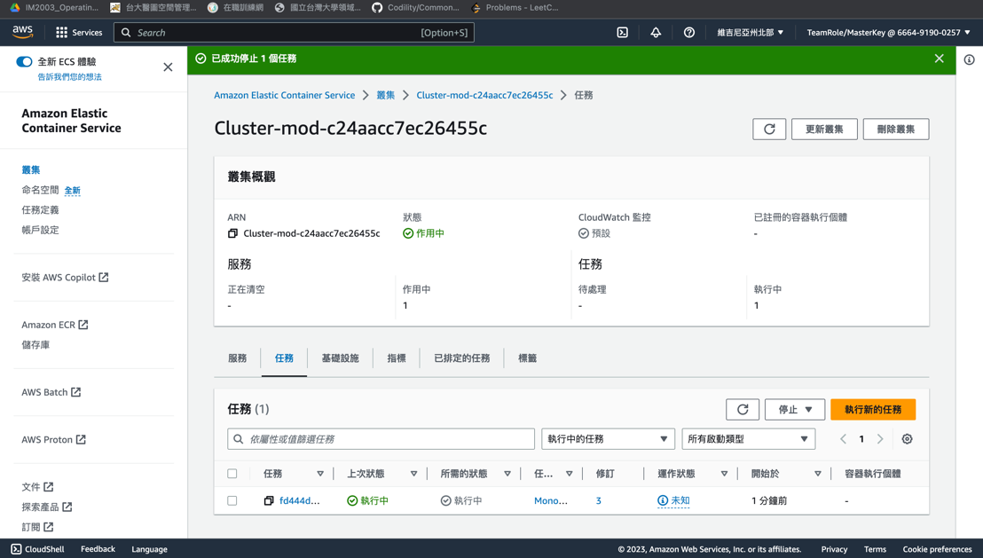

1. Access the website at http://BUCKET_NAME.s3-website.REGION.amazonaws.com

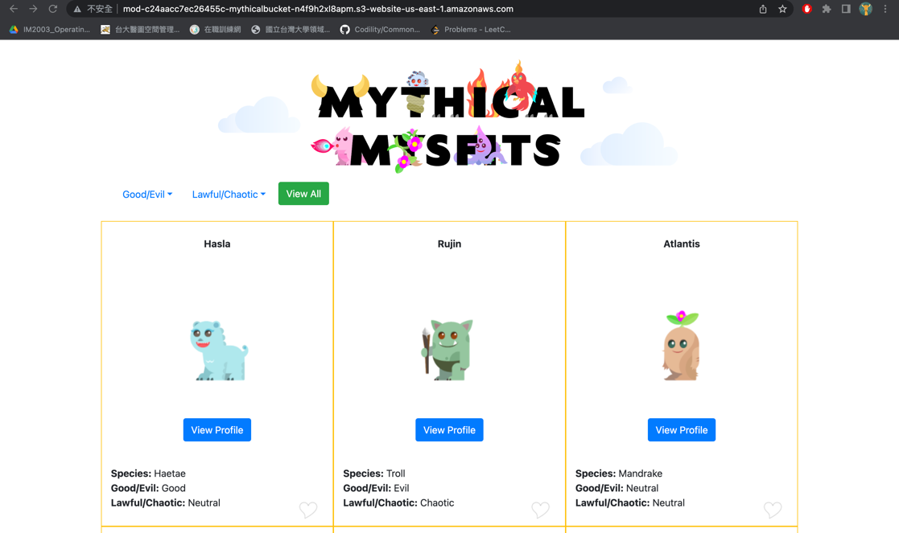

1. Click the heart icon to like a Mysfit

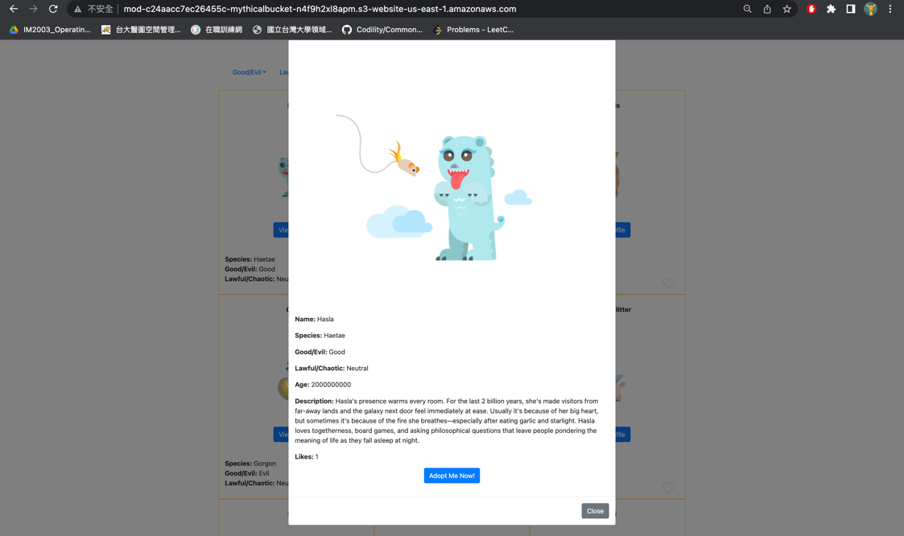

1. Ensure that you can see the "Like processed."

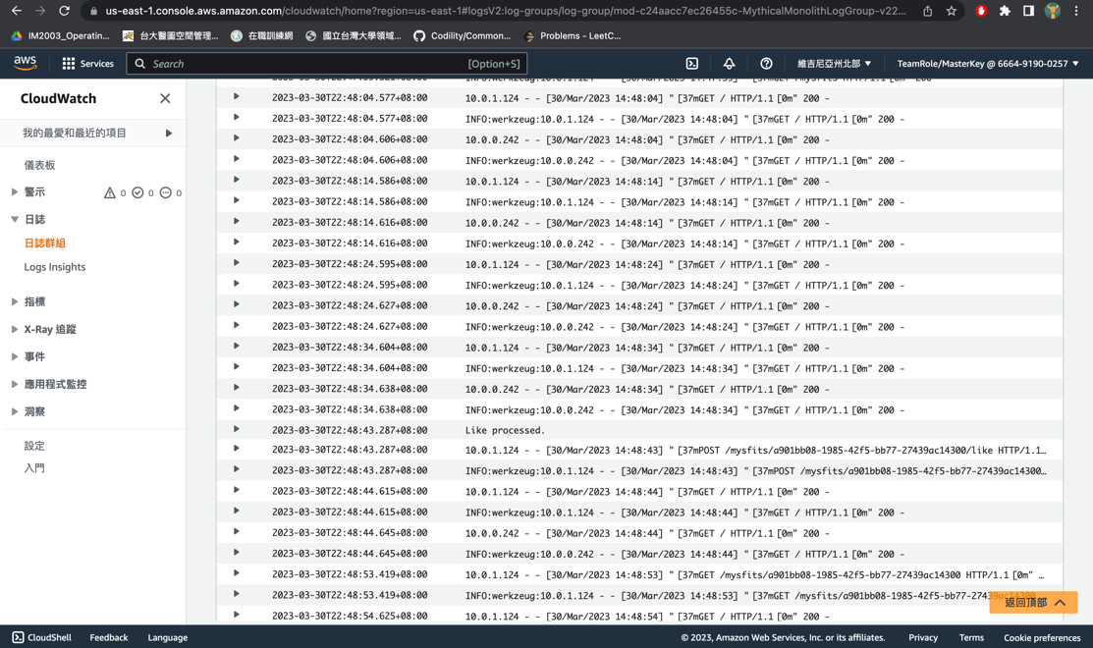

Lab 4

1. Create new task definition revision and update a service

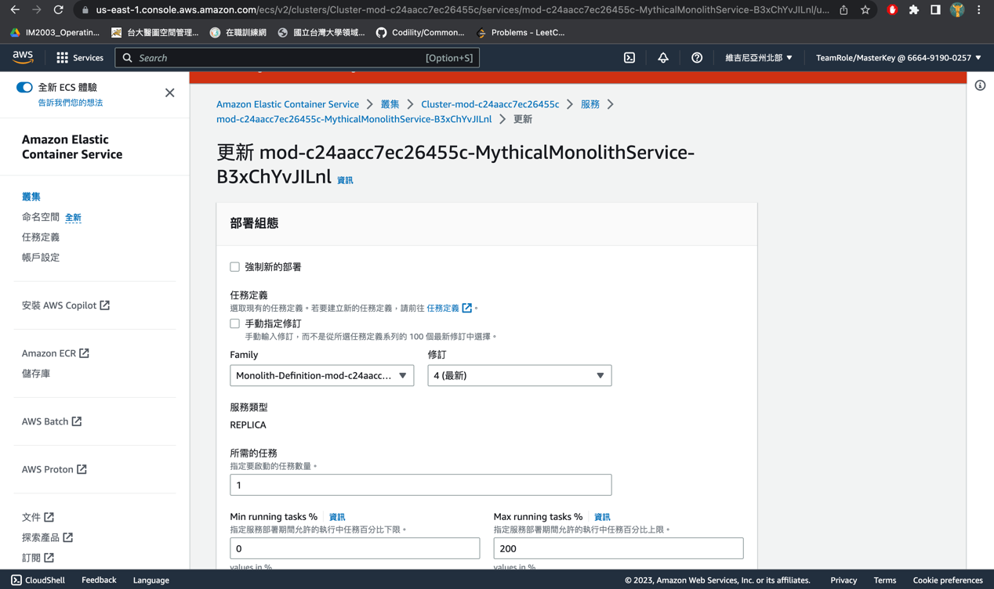

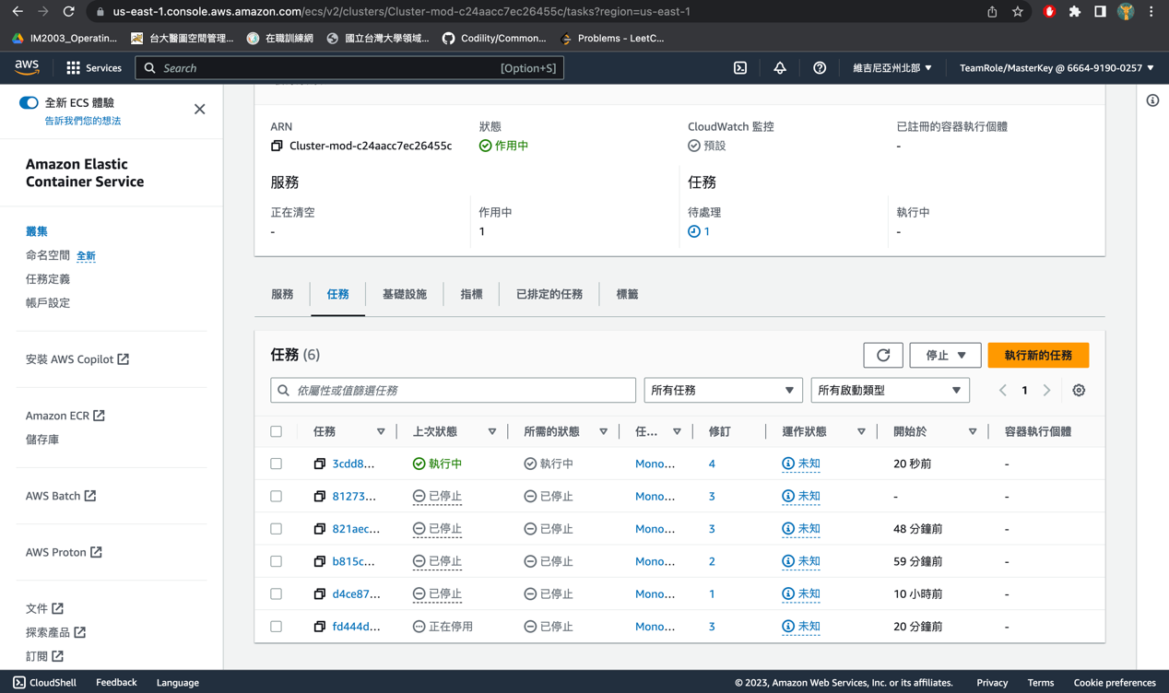

1. Create a new Task Definition for the like service

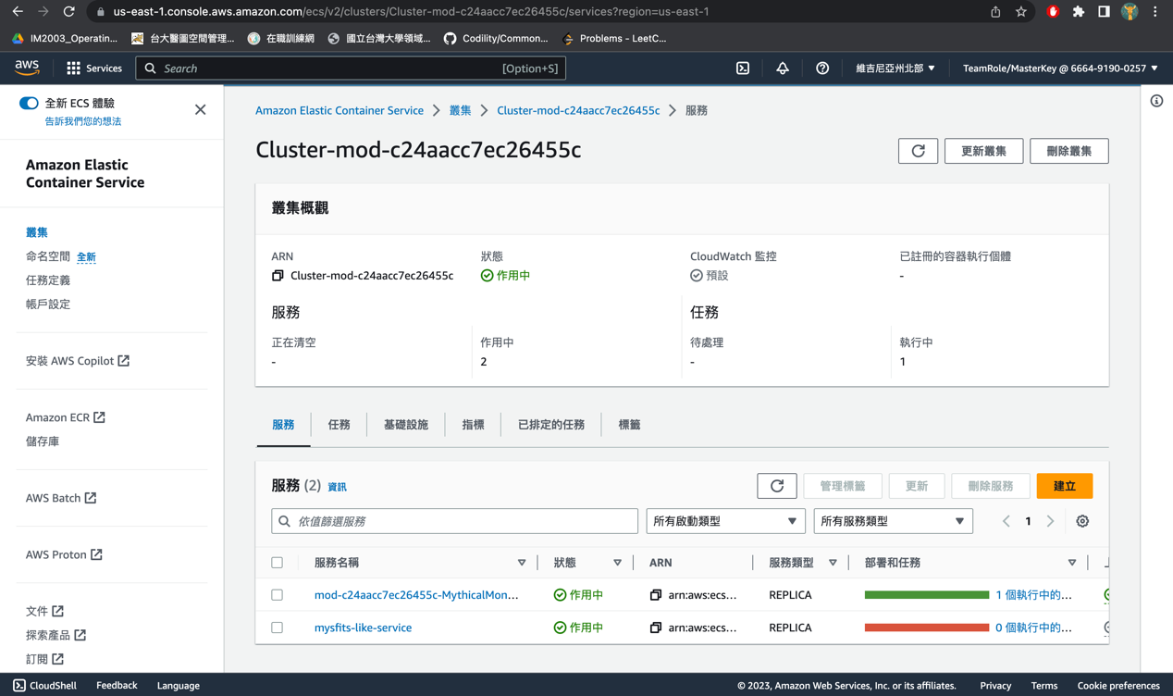

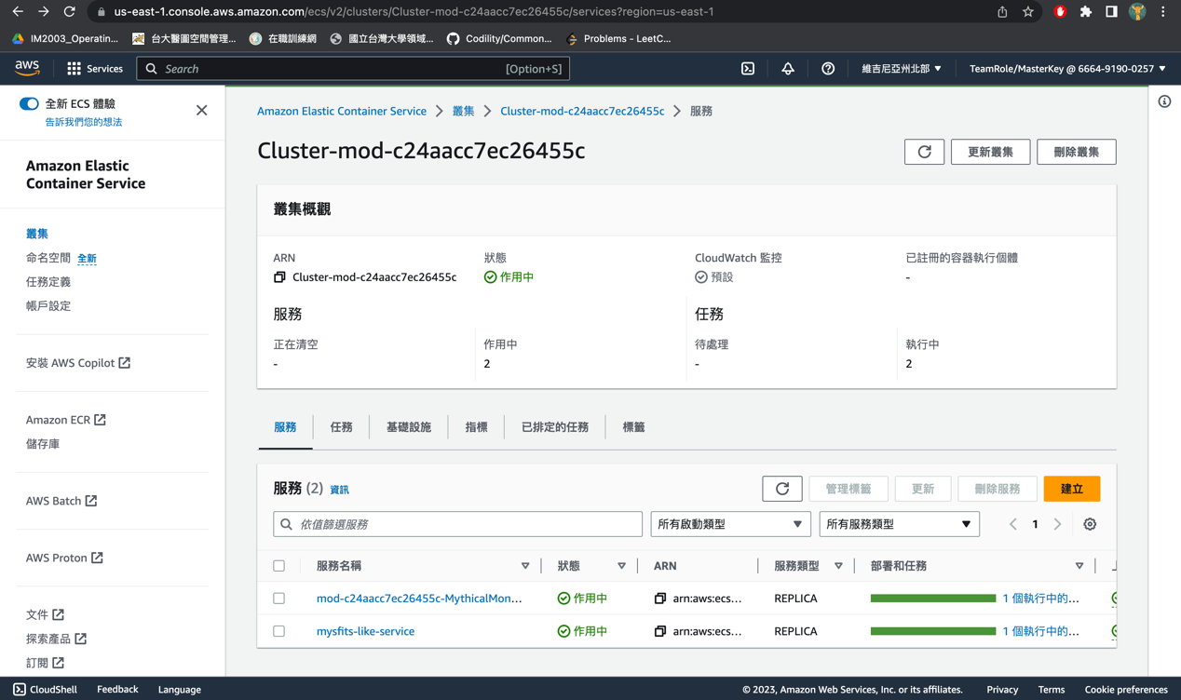

1. Pushed image tagged as nolike2

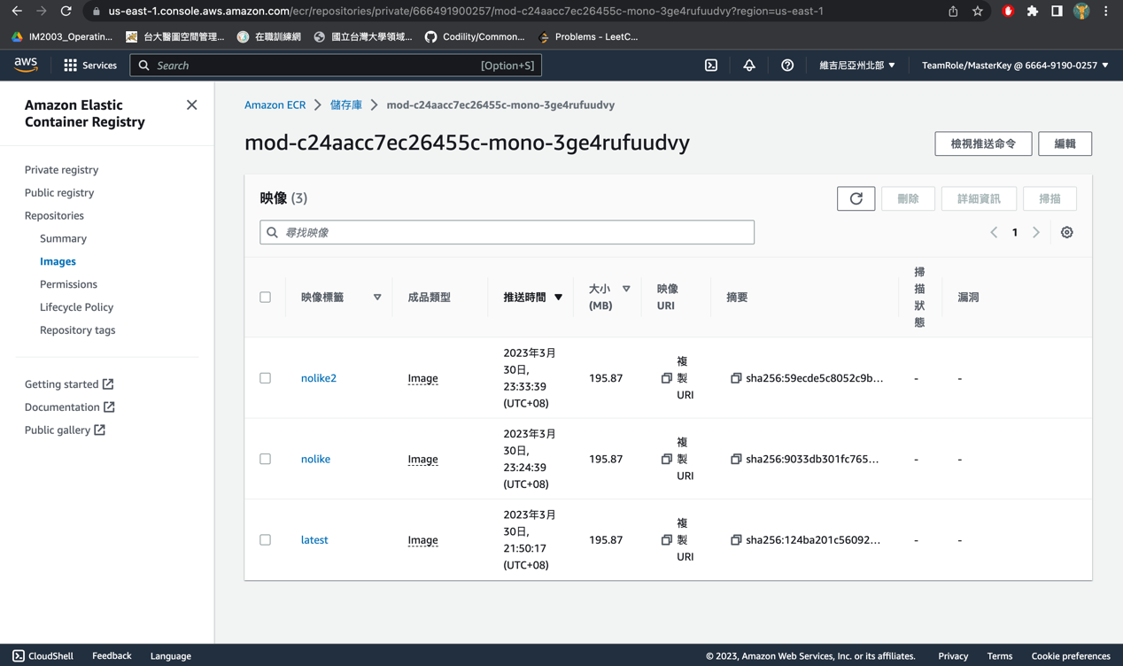

1. Update the monolith service to use the new Task Definition, and make sure the app still functions as before

